PC-1 Tracking Dashboard – Technical Architecture & Implementation Guide (Improved Version)
Version: 1.0
Date: September 2025
Author: Nasir Ali Kazmi
Status: For Review

Table of Contents
- Introduction
1.1. Project Overview
1.2. Document Purpose
- System Architecture
2.1. High-Level Overview
2.2. Technology Stack
2.3. Ingestion Pipeline Flowchart
- Data Model & Database Schema
3.1. Entity-Relationship Diagram (ERD)
3.2. Model Definitions
- Core Module Deep Dive
4.1. Ingestion Services (ExcelIngestionService, WorkbookProcessor)
4.2. Data Models (models.py)
4.3. API Layer (views.py, serializers.py)
4.4. Utilities & Background Tasks (tasks.py, signals.py, file_utils.py)
- Admin & Reporting Interface
- Deployment & Configuration
6.1. Dockerized Environment
- Security, Audit, & Compliance
- Future Enhancements
- Appendix

1. Introduction

1.1. Project Overview
The PC-1 Tracking Dashboard is a modular, audit-ready system designed to automate the ingestion, validation, and reporting of Excel-based field data submissions. It supports donor compliance workflows, granular row-level tracking, and dynamic filtering for MEL teams and government stakeholders, ensuring data integrity and traceability from upload to export.

1.2. Document Purpose
This document provides a comprehensive technical overview for developers, system integrators, and technical stakeholders. It details the system's architecture, data models, API endpoints, and operational workflows to facilitate development, auditing, and maintenance.

2. System Architecture

2.1. High-Level Overview
The system follows a modular backend architecture built with Django, separating concerns into data ingestion, model management, API exposure, and asynchronous task processing. The frontend is served primarily through Django Admin and a REST API, ready for a modern React/Vue.js frontend.

2.2. Technology Stack
Layer | Technology / Purpose
Backend Framework | Django (Python)
Database | PostgreSQL (for JSONField support)
API Layer | Django REST Framework (DRF)
File Processing | Pandas (Excel/CSV), Tabula (PDF)
Task Queue | Celery with Redis Broker
Storage | Local filesystem (cloud-ready)
Containerization | Docker & Docker-Compose

2.3. Ingestion Pipeline Flowchart
The following diagram illustrates the end-to-end flow for processing an uploaded file:
Diagram
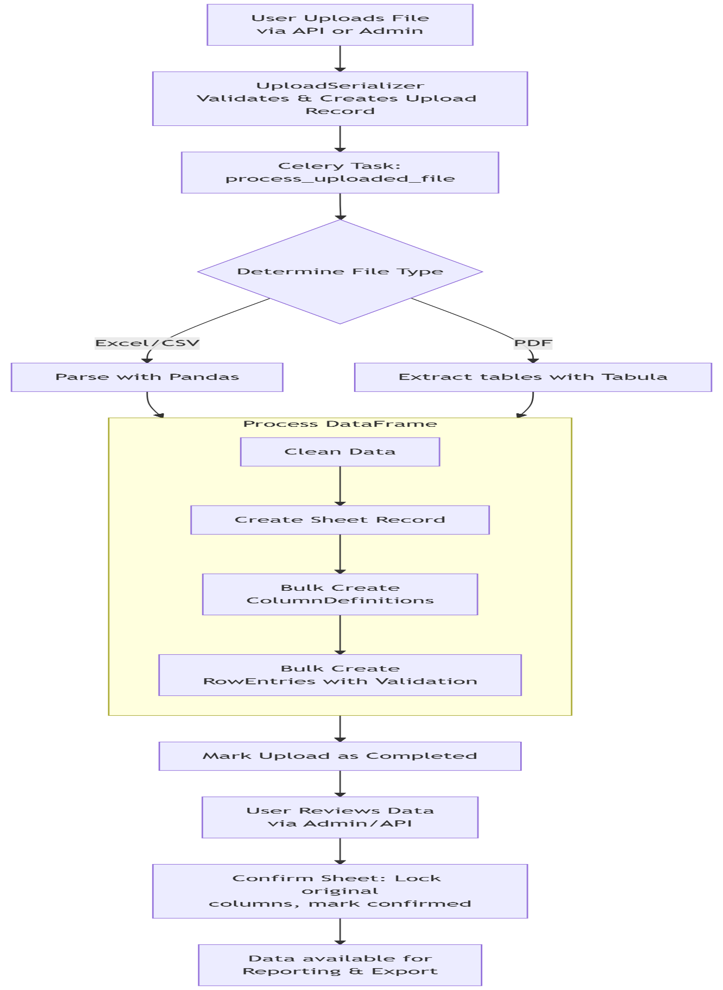

3. Data Model & Database Schema

3.1. Entity-Relationship Diagram (ERD)
The core data model is built around four primary entities, ensuring full auditability and structured storage of original and tracking data.
Diagram
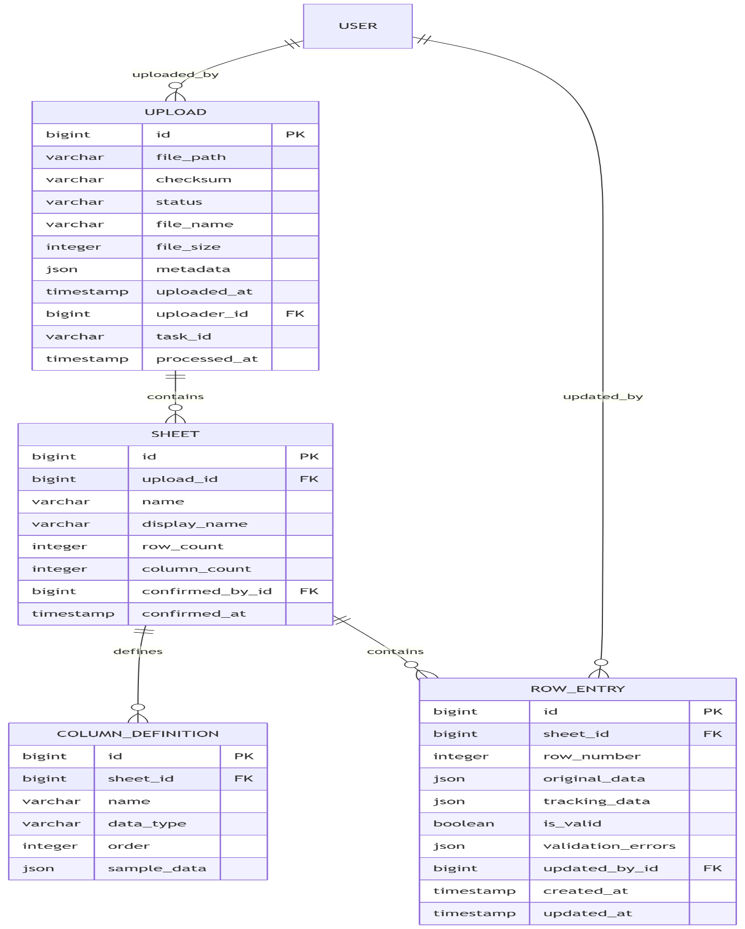

3.2. Model Definitions
- Upload: The central model representing a file submission. Tracks lifecycle (status), origin (uploader), integrity (checksum), and processing metadata (task_id, processed_at).
- Sheet: Represents a single sheet within an uploaded file. Links to its parent Upload and stores metrics like row_count.
- ColumnDefinition: Stores schema metadata for each column in a Sheet (name, data type, position, sample data). Critical for validation and dynamic reporting.
- RowEntry: Stores the core data. original_data holds the immutable raw values from the file, while tracking_data holds editable verification metadata. Validation status is captured in is_valid and validation_errors.

4. Core Module Deep Dive

4.1. Ingestion Services
- ExcelIngestionService: Orchestrates the full ingestion process, coordinating between file handling, parsing, and model persistence.
- WorkbookProcessor: Utilizes pandas and openpyxl to parse Excel workbooks, clean data, and convert sheets into structured JSON for downstream processing.

4.2. Data Models (models.py)
Key functionalities encapsulated in the models:
- Validation: Centralized TRACKING_VALIDATORS dictionary and model clean() methods enforce data integrity for the tracking_data JSONField.
- Auditability: Automatic timestamping and user attribution via updated_by (handled by signals.py).
- Performance: Strategic use of CheckConstraint and indexes on key fields like status and row_number.

4.3. API Layer (views.py, serializers.py)
- ViewSets: UploadViewSet, SheetViewSet, and RowEntryViewSet provide RESTful CRUD operations, custom actions (preview, export, reprocess), and extensive filtering.
- Serializers: Handle validation, transformation, and context-aware serialization (e.g., UploadDetailSerializer for detail views vs. UploadStatusSerializer for lists). The ExcelUploadSerializer is the entry point for file uploads.

4.4. Utilities & Background Tasks
- tasks.py: Contains the primary Celery task process_uploaded_file which asyncronously processes files based on type (Excel, CSV, PDF) and batched database operations for performance.
- signals.py: Uses a pre_save signal on the RowEntry model to automatically set the updated_by field to the current authenticated user, ensuring auditability.
- file_utils.py & excel_processor.py: Utilities for saving files, generating checksums, and protecting Excel sheets by locking non-tracking columns.

5. Admin & Reporting Interface
The Django Admin interface is heavily customized to provide:
- Visual Status Indicators: Badges for upload status and row validity.
- Inline Previews: Of sheets, column definitions, and row data.
- Administrative Actions: Such as triggering reprocessing of an upload.
- Granular Search & Filtering: Based on all key fields, including tracking data.

6. Deployment & Configuration
The system is designed for easy deployment via Docker:
- docker-compose.yml defines services for:
  - web (Django Gunicorn)
  - db (PostgreSQL)
  - redis (Celery Broker)
  - celery-worker (Background task processor)
- Environment variables configure sensitive data and deployment-specific parameters.

7. Security, Audit, & Compliance
- Authentication: Django's auth system restricts API and Admin access.
- Auditability: Every data change is attributed to a user and timestamped. File checksums prevent tampering.
- Data Integrity: Original data is locked in confirmed sheets; only designated tracking fields are editable.

8. Future Enhancements
Planned improvements include:
- Frontend Application: A dedicated React/Vue.js app for improved UX.
- Advanced Reporting: Custom report builder with visualizations.
- Enhanced Role-Based Access Control (RBAC): Granular permissions for different user types (MEL, Field Staff, Donors).
- System Integration: APIs for bidirectional sync with other MEL platforms.

9. Appendix
(This section would hold sample payloads, example screenshots of the admin interface, and detailed configuration examples.)

